**Facebook Data Analysis**

1. **Find out the total no of users in the dataset.**

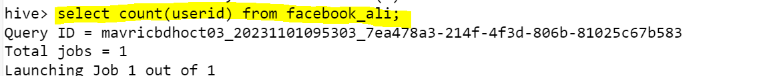

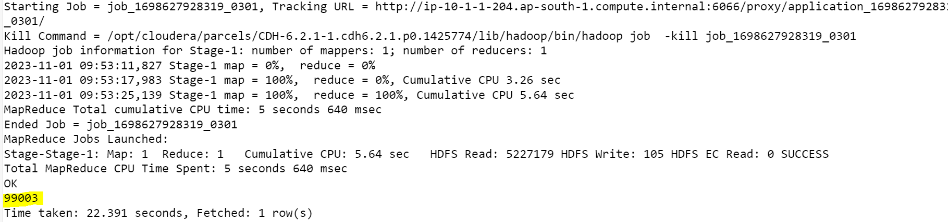

1. **Find out the no of users above the age of 25.**

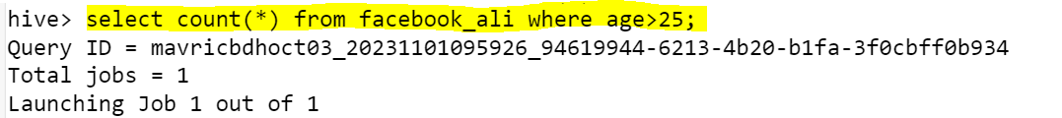

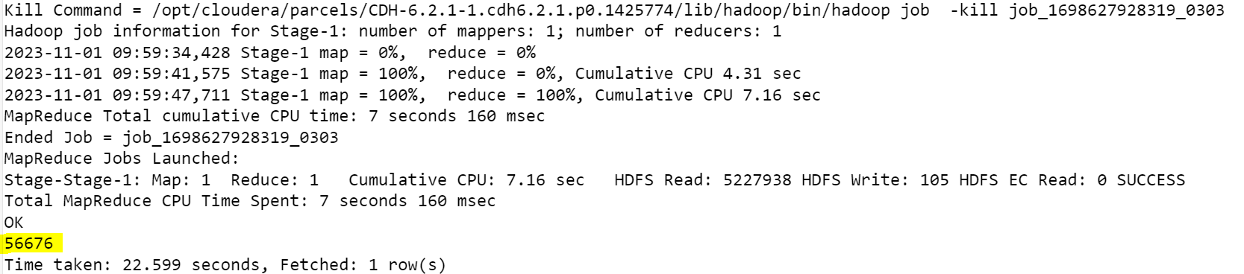

1. **Do male face book users tend to have more friends or female users.**

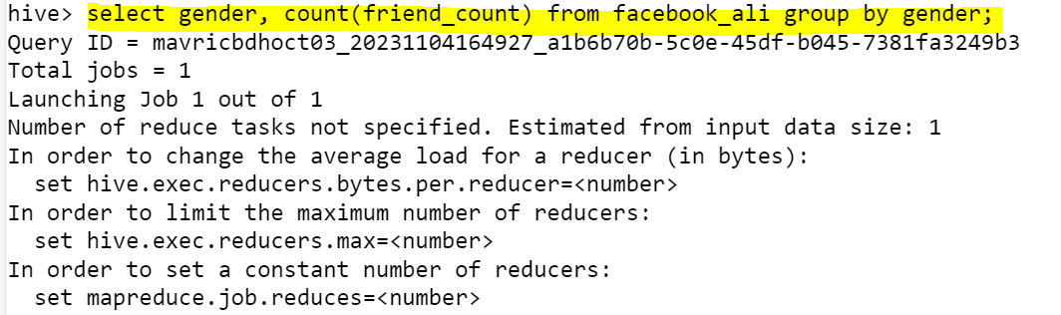

1. **How many likes do young people receive on facebook as opposed to old people.**

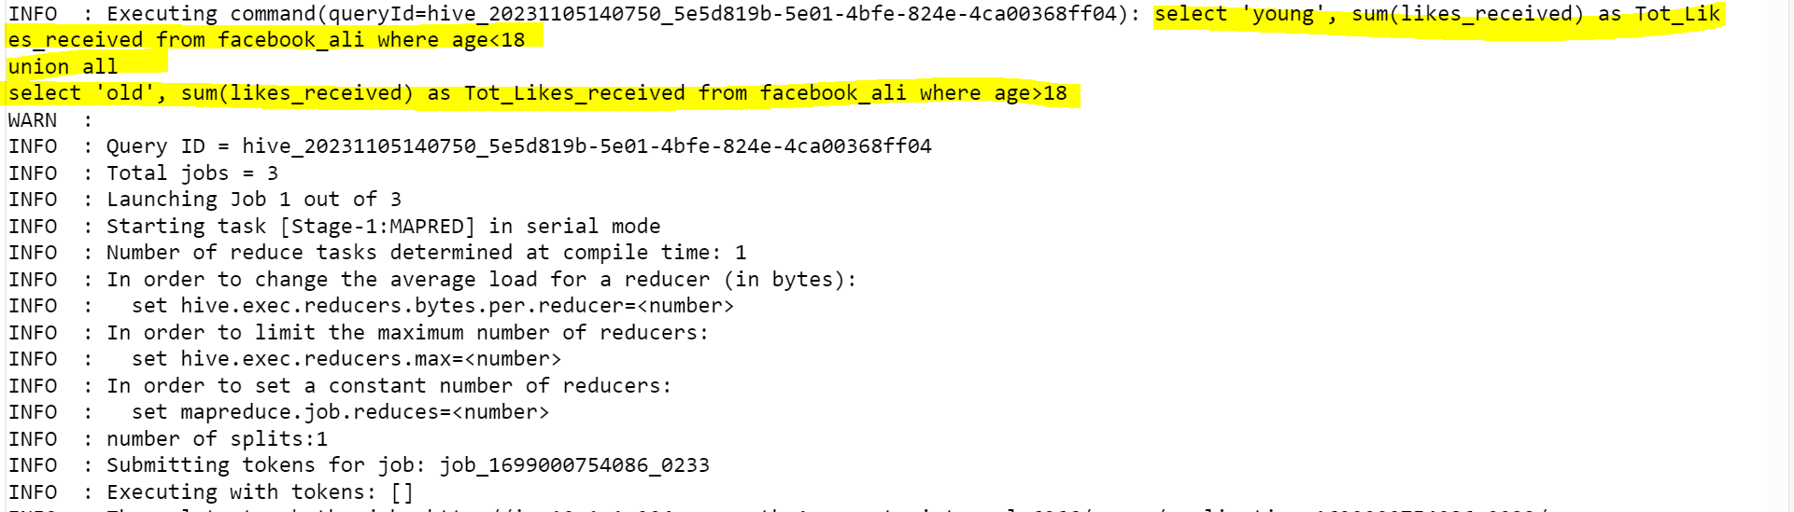

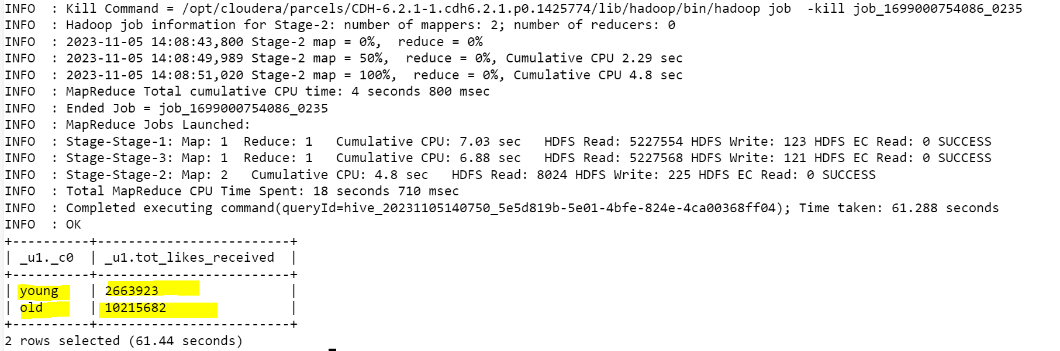

1. **Find out the count of facebook users for each birthday month.**

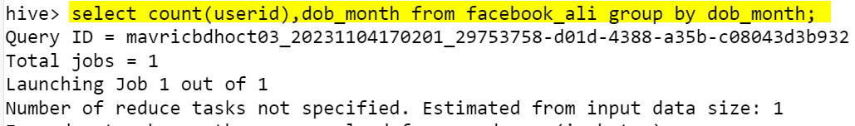

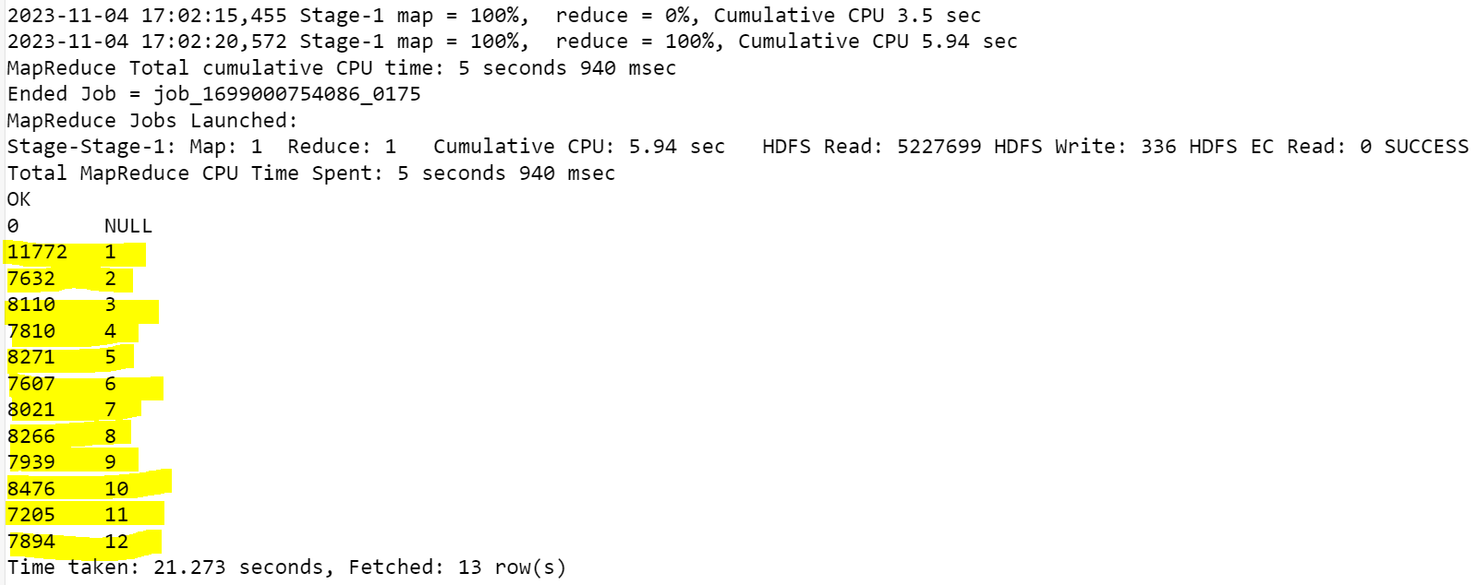

1. **Do young members use mobile phones or computers for facebook browsing.**

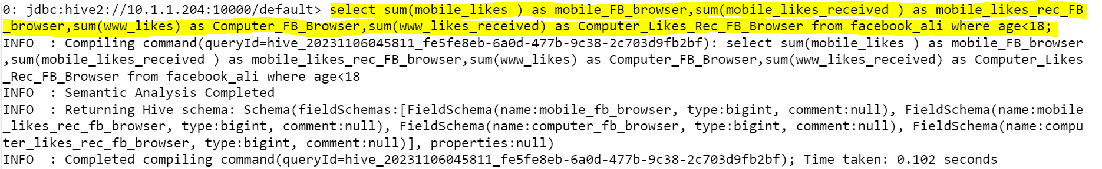

1. **Do adult members use mobile phones or computers for facebook browsing.**



